Analysis Script Execution and Result Directory Mapping
Overview of the Python-Based Correlation Analysis Pipeline

1. Purpose
This document describes how each Python analysis script is executed and how its outputs are organized into corresponding result directories.
The purpose of this guide is to provide a clear one-to-one mapping between:
- analysis scripts,
- console execution steps, and
- generated result folders and files.

2. Analysis Directory Overview
All analysis scripts and input data are located in a single working directory.
Figure 1. Overall directory structure containing Python analysis scripts, input video, and result folders.
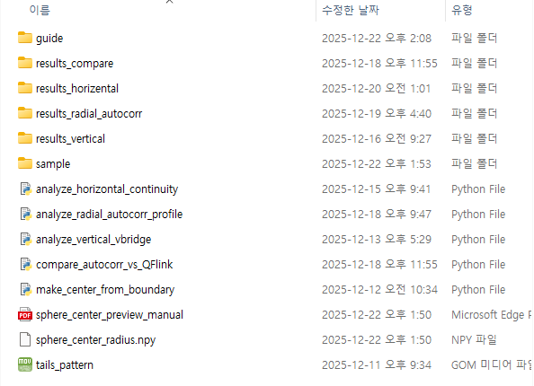
Key elements:
- Python scripts (*.py)
- Input video file (tails_pattern.mov)
- Result directories:
  - results_horizontal/
  - results_vertical/
  - results_radial_autocorr/
  - results_compare/

3. Horizontal Spatial Continuity Analysis

3.1 Script Execution
The horizontal spatial continuity analysis is performed by executing:
analyze_horizontal_continuity.py
When executed, the script:
- loads the input video tails_pattern.mov,
- reads the sphere center and radius from sphere_center_radius.npy,
- initializes patch-based sampling along the horizontal (radial) direction.
Figure 2. Console output during execution of analyze_horizontal_continuity.py.
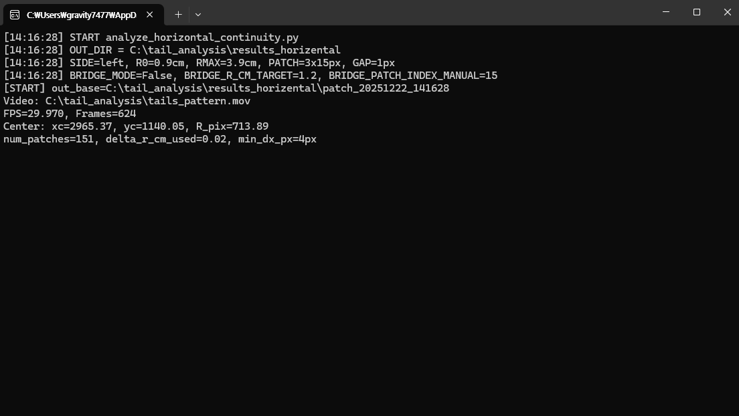

3.2 Generated Results
Upon completion, a new timestamped subdirectory is created inside:
results_horizontal/
This directory contains:
- horizontal continuity maps,
- run-length histograms,
- radial profiles of correlation strength and time lag,
- summary text files and NumPy data files.
Figure 3. Files generated in the results_horizontal directory after horizontal continuity analysis.
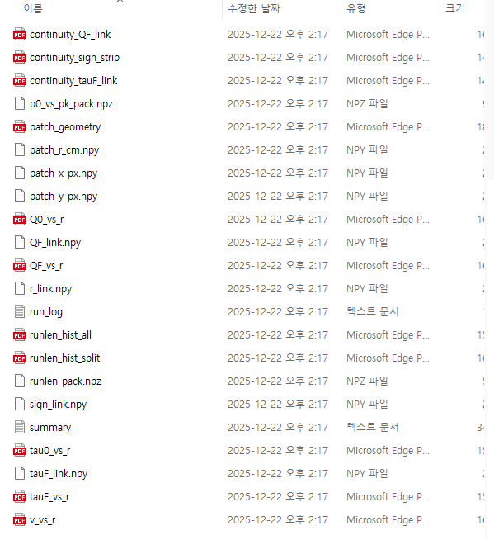

4. Vertical Synchronous (Bridge) Analysis

4.1 Script Execution
Vertical synchronous analysis at a fixed radial anchor is performed by executing:
analyze_vertical_vbridge.py
This script:
- uses a fixed radial position,
- extracts vertically separated intensity traces,
- computes zero-lag correlation matrices to assess temporal synchrony.
Figure 4. Console output during execution of analyze_vertical_vbridge.py.
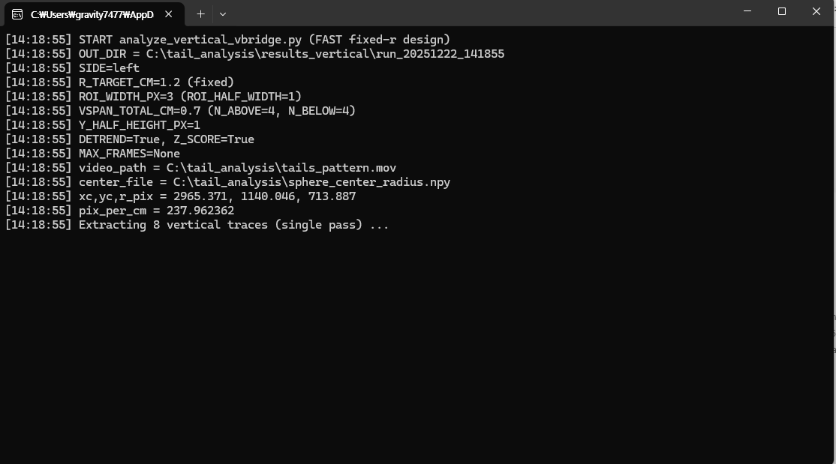

4.2 Generated Results
The script generates a timestamped result directory inside:
results_vertical/
This directory includes:
- vertical correlation matrices,
- trace previews,
- synchrony visualization plots,
- associated NumPy and text files.
Figure 5. Files generated in the results_vertical directory after vertical synchrony analysis.
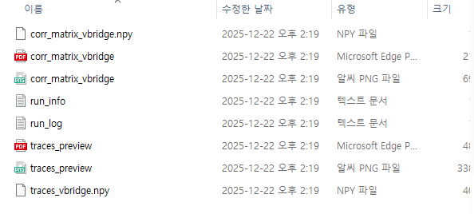

5. Radial Temporal Persistence Analysis

5.1 Script Execution
Radial temporal persistence is analyzed by executing:
analyze_radial_autocorr_profile.py
This script:
- samples intensity time series along the radial direction,
- computes temporal autocorrelation functions,
- evaluates time persistence as a function of radial distance.
Figure 6. Console output during execution of analyze_radial_autocorr_profile.py.
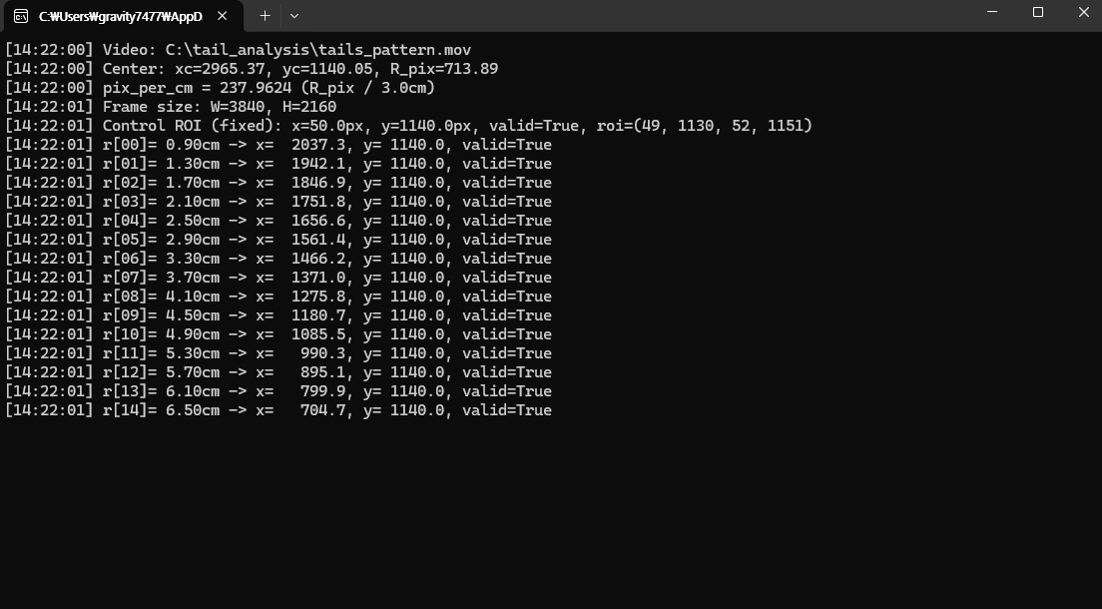

5.2 Generated Results
The outputs are written to a timestamped directory inside:
results_radial_autocorr/
Generated files include:
- autocorrelation curves,
- radial autocorrelation maps,
- persistence metrics,
- summary logs and data tables.
Figure 7. Files generated in the results_radial_autocorr directory after radial autocorrelation analysis.
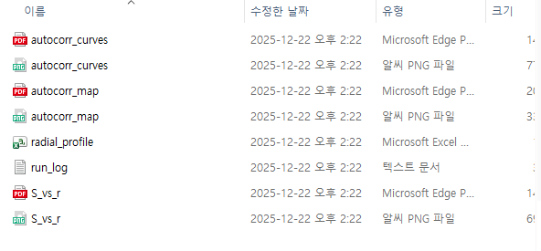

6. Comparative Analysis: Continuity vs Temporal Persistence

6.1 Script Execution
A final comparative analysis is performed using:
compare_autocorr_vs_QFlink.py
This script:
- automatically selects the most recent result directory from results_horizontal/,
- automatically selects the most recent result directory from results_radial_autocorr/,
- compares spatial continuity metrics with temporal persistence metrics.
Figure 8. Console output during execution of compare_autocorr_vs_QFlink.py.
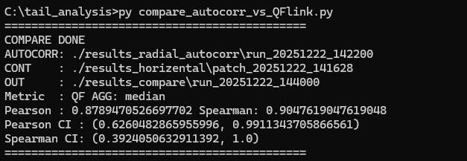

6.2 Generated Results
Comparison results are stored in:
results_compare/
These files quantify:
- the correspondence between spatial continuity and temporal persistence,
- agreement between horizontal correlation structure and radial memory effects,
- summary plots and comparison statistics.
Figure 9. Files generated in the results_compare directory after comparative analysis.
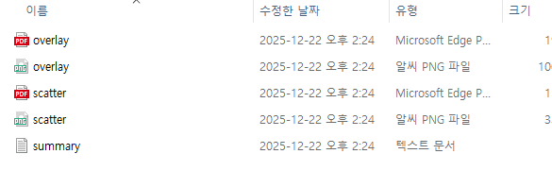

7. Summary of the Analysis Flow
The complete analysis pipeline proceeds as follows:
- Execute make_center_from_boundary.py → define sphere geometry
- Execute analyze_horizontal_continuity.py → spatial continuity
- Execute analyze_vertical_vbridge.py → vertical temporal synchrony
- Execute analyze_radial_autocorr_profile.py → temporal persistence
- Execute compare_autocorr_vs_QFlink.py → continuity–persistence comparison
Each script produces outputs in a dedicated result directory, ensuring traceability and reproducibility.

